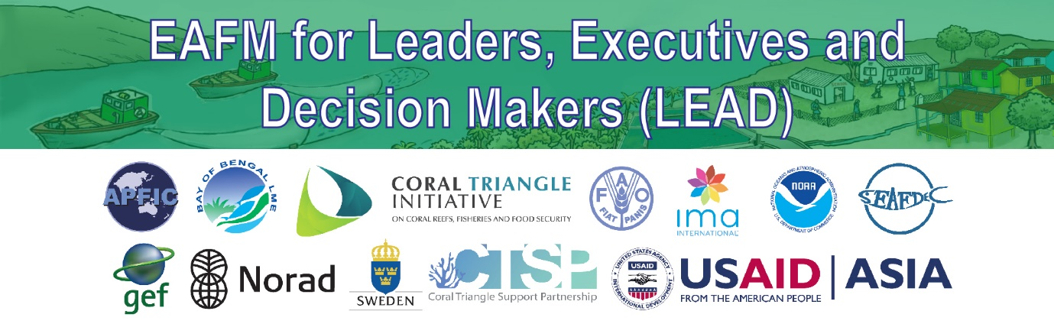
Using the LEAD toolkit
The LEAD toolkit contains a number of tools that can be used with different audiences and in different situations. This matrix provides guidance on what tools can be used when addressing different audiences and in different situations ranging from a casual meeting (elevator, lunch, other meetings) to a 1-day formal high level consultation.

The matrix is intended only as a guide, and many variations can be used.

EAFM LEAD SITUATION | AUDIENCE  (examples, try to include at least one strong EAFFM supporter that is from the key agency & someone who represents the office that would apply EAFM) | - BROCHURE  & FLYERS | - CONVERSATIONS | - ANIMATIONS | - VIDEOS | - POSTERS | - POWERPOINTS | - REREENCE MATERIALS  (e.g. FAQs) | 8. KEY TERMS | 9. ACTIVITIES
Casual meeting (elevator, lunch, other meetings) | All LEADers
5-10 min greeting in LEADers office | LEADers + advisors and junior staff who accompany them
5-10 min meeting with political leader | Religious or fisheries leader, politicians or advisors to senior fish or environment ministries
1 hour consultation held in meeting room | Advisors or consultants to govt or project, key support staff and someone w/ decision making powers
2 hour consultation held in meeting room | Advisors or project managers, more senior staff, include at least 1 key decision maker
Half-day consultation held in meeting room | Mix of junior & senior staff include 1+ advisors & key decision makers.
1-day consultation with experts in meeting room | Junior level (technical) agency employees + advisor or someone connected to LEADers
1-day consultation with general audience (e.g. introducing theconcept to interested parties) | General public officials; local communities or provincial/ municipal level bureaucrats + include a technical fisheries person

